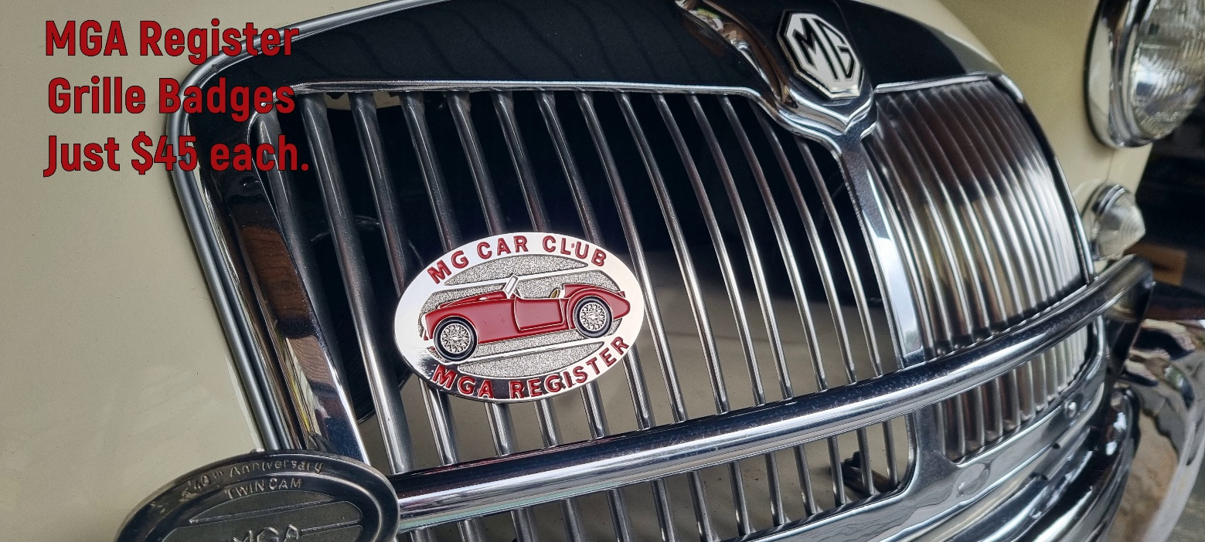
High quality, MGA Register Grille badges in Red, BRG, Black, White or Blue now available at $45 each (including postage).
Pins for securing the badges are 2.5 mm long, M6 with nuts and horizontal orientation (54mm between the pins).
You can secure yours now by completing the attached and return to greg.manderson@mgcc.com.au

Name:
Mobile Phone
e-mail address
Street Address
Suburb / Town
State
Post Code
Colour Required
Quantity Required

Once received, we will confirm receipt of your order and allocate badge(s) accordingly until stock is fully depleted.
With confirmation please make payment of $45 per badge to:
MGA Register
BSB: 083 419
A/C: 897141544
We will then post via Australia Post to your nominated address.
Best Regards
MGA Register, MG Car Club Victoria

